PARKHOUSE

Building Contractors

Chasers Cottage

8 Crimscote

Stratford on Avon

Tel. 01789 459558

Mobile. 07960 396080

**South Warwickshire Local Plan – Part 1**

**Stage 2 : Issues and Options : January 2023**

**Response on behalf of Mr D Stephenson**

Stratford-on-Avon District Council The SWLP Team, Stratford -on-Avon District Council Elizabeth House, Church Street, Stratford-upon-Avon, CV37 6HX

[swlp@stratford-dc.gov.uk](mailto:swlp@stratford-dc.gov.uk)

1. **Introduction**

These representations have been prepared on behalf of Mr D Stephenson in response to the South Warwickshire Local Plan Part 1 *Issues and Options* consultation. Mr Stephenson has previously submitted his land, which abuts the Long Marston New Settlement, into the Call for Sites (Site reference 74).

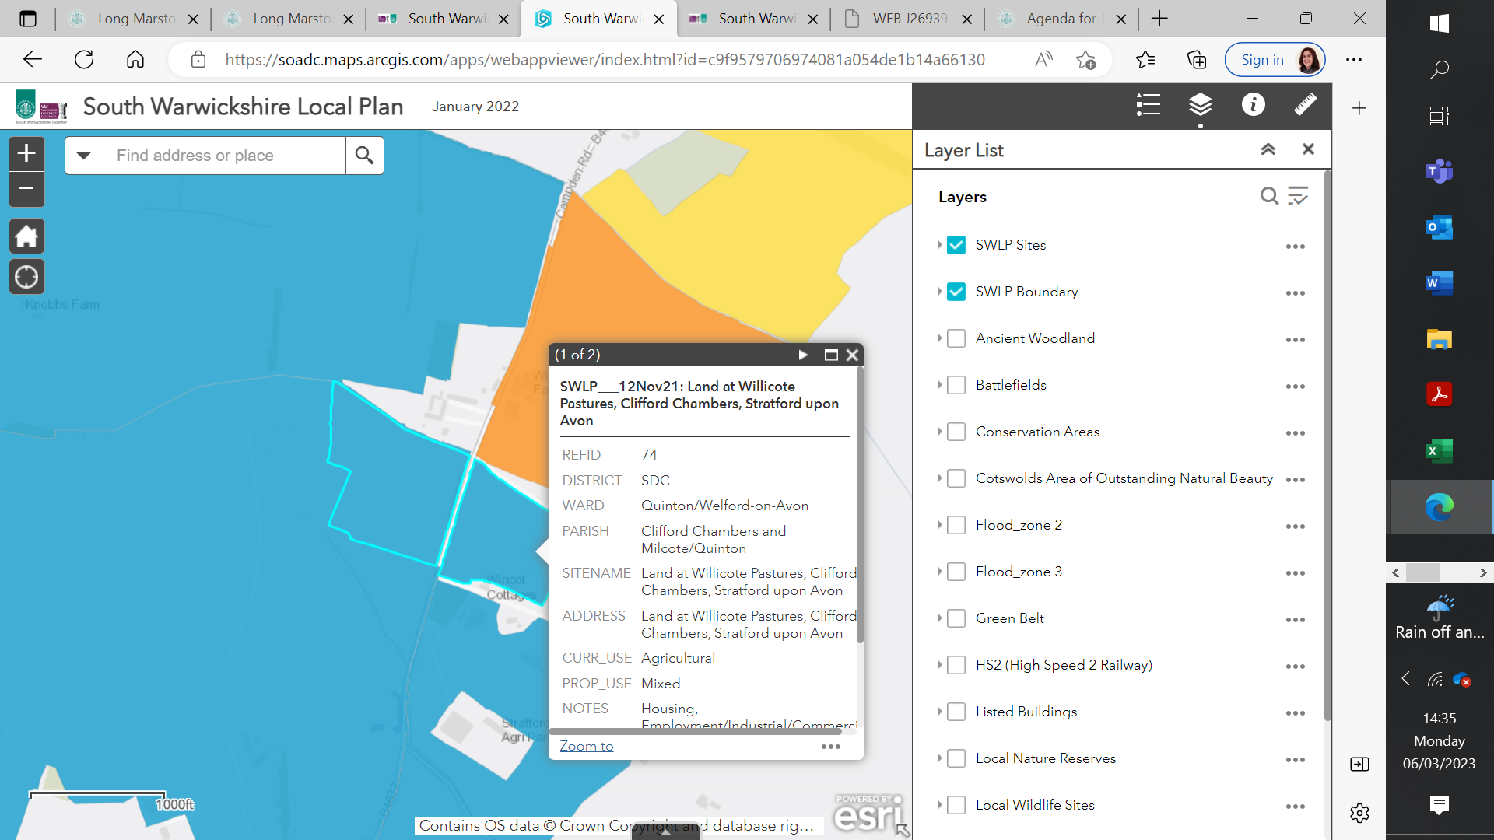

This response is directed at various questions posed on the consultation document, with a specific focus on the spatial strategy and development requirements.

We are firmly of the view that the Local Plan strategy should include provision for further extensions to the Long Marston New Settlement for both housing and employment uses and as is proposed in the five spatial options presented in the Issues and Options Consultation Document.

Whilst priority should be given to previously developed land, the evidence presented within the Issues and Options document demonstrates that, as a matter of principle, greenfield sites must form part of the strategy in order to meet objectively assessed needs in the plan period**.**

Consolidating and expanding the New Settlement, which currently has planning permission for 3,500 new homes, significant employment space, three schools, and a mixed-use village centre, will enhance the sustainability and resilience of this settlement and support the natural growth of this new community, complementing the Vision set out in the Adopted SPD of “a thriving new Garden Village that offers the best of town and country living”.

The site itself is a natural extension to the Long Marston Garden Village adjacent to Pillbox Park and close to the Village Centre.

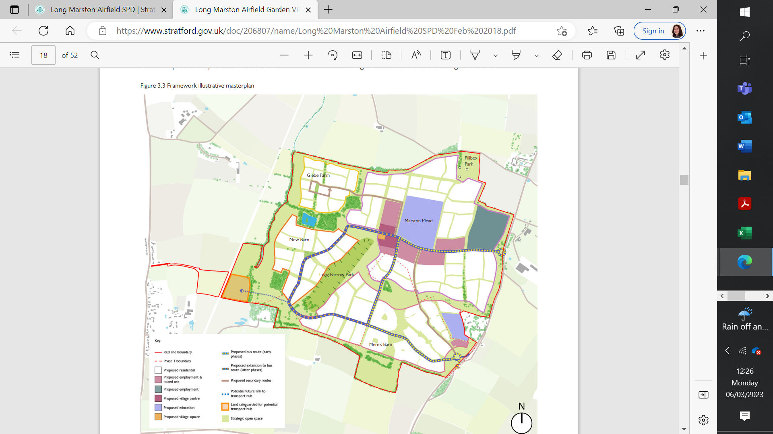

The Site

1. **Vision and Strategy : Question V 3.1**

This Section of our representations comments on the proposed Vision and proposed Strategic Objectives.

We support both the Vision, the Strategic Objectives. We note that the Vision and Strategic Principles for Long Marston were originally set out in the adopted SPD dated February 2018 and that some degree of updating will be required to bring this in line with the emerging Vision within the South Warwickshire Local Plan; specifically in terms of climate resilience and sustainable modes of travel. This will not however undermine the key design principles or jeopardise options for further growth at Long Marston Garden Village.

The Strategic Objectives are important in providing a greater level of detail

We agree with the Strategic Objectives and draw particular reference to “Meeting South Warwickshire’s Sustainable Development Needs”. This will require a strategy to ensure the delivery of objectively assessed housing needs through a range of homes, on a portfolio of sites.

**3.** **Meeting South Warwickshire’s Sustainable Development Needs : Question S 7.2**

This section addresses Section 4 of the Consultation Document.

We agree that the Local Plan’s primary role is to promote a sustainable pattern of development that seeks to meet the needs of South Warwickshire, align growth and infrastructure, improve the environment, mitigate climate change and adapt to its effects but equally there should be a clear commitment to provide sufficient land to meet both housing and economic needs within a spatial strategy, aimed at achieving the most sustainable pattern of development.

In this context it is important to deliver a portfolio of sites and not rely on one option – referred to as a Hybrid Strategy in the consultation document.

The consultation document refers to this approach as providing a balance of growth at existing main settlements, some growth at new settlement scale, and more modest growth in smaller settlements, which can contribute to enhancing the viability of village centres and provide affordable housing.

The reference to “new settlements” should not only be confined to “new” new settlements which have significant lead in time for delivery and therefore cannot meet short and medium term needs but should also recognize the need to continue to grow and sustain existing new settlements such as Long Marston which are already delivering.

This approach will support the viability and vitality of these new areas of growth and provide further investment for

* Sustainable transport connectivity
* Green infrastructure,
* Renewable and low carbon energy generation to mitigate the effects of and adapt to climate change.
* Services and facilities in the village centre
* Community facilities and schools

Further housing and economic growth in existing new settlements will also enhance opportunities for containment and reduce the need to travel.

This approach will protect the West Midlands Green Belt in the north of the plan area and the Area of Outstanding Natural Beauty in the south of the Plan area and avoid the negative effects of the dispersal strategy illustrated in the Sustainability Appraisal (Table 7.1)

It is important to note at this stage that further growth at Long Marston appears in all of the options in Section 7 and this approach is supported.

**Green Belt**

We note that some of the assessment work has been undertaken with a “policy off” position applied to the Green Belt designation. However, Green Belt policy in the NPPF only permits the amendment of the Green Belt where exceptional circumstances exist (para 140). For exceptional circumstances to be justified, it is necessary to examine fully all other options for meeting the identified need for development. This requires an assessment of Green Belt and non-Green Belt locations.

In this instance, other development options including further growth at Long Marston can be seen to perform better than Green Belt locations and, on this basis, the exceptional circumstances would not be met. In this context sites within the Green Belt would need to be materially better than non-Green Belt locations in order to be preferred as future locations for growth. That plainly is not the case and those non-Green Belt locations identified in the Strategic Options should be prioritized.

1. **Delivering Homes to meet the needs of all of our communities : Question H 1.1**

The evidence base concludes that Stratford-on-Avon and Warwick are the least affordable areas in the Coventry and Warwickshire sub-area and it important therefore that the Strategy focuses growth both within these towns and in locations which are close to and easily accessible to these towns – including Long Marston. The affordability crisis will be further exacerbated if the Local Plan provides too few houses, either by a policy choice not to meet the objectively assessed level of housing need, or by adopting a housing strategy that cannot deliver sufficient housing to meet the needs. Relying on the delivery of new “new settlements” could result in such a risk to the overall strategy.

The consultation document notes that *“whilst it may be tempting to want to apply the 2014-based figures because they are lower for South Warwickshire, given that Coventry looks unable to accommodate all of its own housing needs, it would most likely fall to South Warwickshire to accommodate a significant quantum of that need. The outcome would then most likely be similar levels of housing as shown in the 10-year trend-based projection”*. It would be wrong therefore to adopt a Local Plan that was not based on the scale of housing which is adjusted to accommodate neighbouring need. And on this basis, the housing requirement should be the higher of the two suggested figures.

Based on the evidence of potential existing housing supply in the Urban Capacity study this would suggest a residual need for some 22,000 new homes to be provided over the plan period.

**6. Summary**

This response to the South Warwickshire Local Plan Issues and Options consultation has been prepared on behalf Mr D Stephenson who is generally in support of the proposed Strategy. Specifically, we support the proposal that the housing requirement should be based on the HEDNA exercise which indicates a need over the plan period of some 40,000 new homes.

We agree that based on the evidence of potential existing housing supply this would suggest a residual need for some 22,000 new homes to be provided over the plan period.

We maintain that to deliver this level of housing green field land will be required.

We note that the Spatial Strategy is likely to require a hybrid approach and we support the identification of further growth at Long Marston New Garden Village in all of the presented options.

As a more detailed strategy evolves for further growth at Long Marston New Garden Village, we would like to commend the merits of Site 74 which forms a natural extension to the Long Marston Garden Village adjacent to Pillbox Park and close to the Village Centre.



PARKHOUSE

Building Contractors

Chasers Cottage

8 Crimscote

Stratford on Avon

Tel. 01789 459558

Mobile. 07960 396080